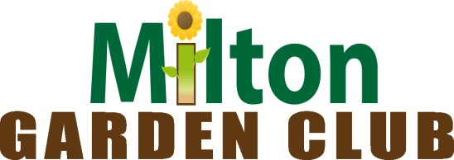
2025 Application - $3,000 Post-Secondary Student Scholarship

The Milton Garden Club is now accepting applications for the 2025 Milton Garden Club Post-Secondary Student Scholarship for full-time students attending colleges or universities in the State of Delaware including University of Delaware, Delaware State University and Delaware Technical & Community College. The number of scholarships awarded is based on the number of qualified applicants.

ELIGIBILITY:
- Applicants must be returning sophomores, juniors or seniors enrolled full-time in a college or university in the State of Delaware studying in the field of agriculture and natural resources.
• Applicants must be legal residents of Sussex County, Delaware.

CRITERIA:
- Applicants must demonstrate a commitment to the study of landscape and ornamental horticulture; plant science including sustainable landscapes, production horticulture, plant pathology, plant biology and genetics, soils and environmental quality; landscape design and architecture; agribusiness marketing and management or another similar related field.

- Applicants will be judged on the following criteria:
  - Financial need
  - Scholarship Achievement
  - Community service, leadership and activities in and out of school as relates to chosen field of study

The application deadline is April 1, 2025. Applications can be submitted any time prior to and including the April 1st deadline. The completed application package should be returned to Carol Mertes-Smith, Scholarship Chair at: cmertess@comcast.net or mailed to: Milton Garden Club, Inc., c/o Scholarship Committee, P.O. Box 203, Milton, DE 19968

MILTON GARDEN CLUB POST-SECONDARY STUDENT SCHOLARSHIP APPLICATION
Please type or print clearly.

Applicant's Name___________________________________________

Address___________________________________________________

Phone_____________________________________________________

Email_____________________________________________________

College or University Attending________________________________

Academic Average___________________________________________

Field of study_______________________________________________

INSTRUCTIONS

Please attach the following to this application:
- School transcript with current grades and GPA
- A one-page typed essay describing your current studies, school involvement and community service as they relate to your field of study. Include any future plans as they relate to horticulture, plant science, agriculture or related studies, including how you hope to use your degree to serve your community.
- A financial need statement not to exceed one page. Include an explanation of your need for a scholarship that includes any form of financial assistance, scholarships or grants you expect to receive.
• A letter of recommendation from a faculty member in your field of study.

A complete copy of your application can be submitted any time up to April 1, 2025. All applications must be received no later than April 1, 2025. Completed application packages should be emailed to Carol Mertes-Smith,
Scholarship Chair at: cmertess@comcast.net or mailed to: Milton Garden Club, Inc., c/o Scholarship Committee, P.O. Box 203, Milton, DE 19968

